

**ASDA Warrington**

**MAWM MHE Message Guide**

MESSAGE TYPES

Legacy: StockDifference

MAWM: STOCKDIFFERENCE

**PUSH POSSIBLE®**

Contents

Document Revision History 3

Introduction 3

2.1 Terminology 4

Message Purpose and Creation 5

Message Configuration 5

4.1 Payload Message Type 6

4.2 SOURCE Transport (Only required to be configured once for INBOUND Messages) 7

4.3 SOURCE Endpoint (Only required to be configured once for INBOUND Messages) 8

4.4 SOURCE Subscriber 9

4.5 DESTINATION Transport 10

4.6 DESTINATION Endpoint 11

4.7 DESTINATION Subscriber 12

4.8 Message Routing Strategy UI 13

4.9 Inbound Message Type 14

JSON Example Output 15

5.1 Message Format 15

5.2 Escaping of Special Characters 15

Message Mapping MHE fields to MAWM Fields 16

MHE Journal 16

MHE Message Enrichment 16

1. Document Revision History

|  |  |  |  |
| --- | --- | --- | --- |
| Changed By | Date | Version | Revision Notes |
| Manraj Basati | 17/01/2023 | v0.1 | Initial draft |
| Ben Berridge | 19/01/2023 | v0.1 | Mapping and JSON updates |
| Manraj Basati | 07/02/2023 | v0.2 | Added JSON to section 5.1 |
| BB, MB | 17/03/2023 | v0.3 | Mapping and JSON updates |
| MB | 21/03/2023 | v0.4 | JSON update |
| MB | 31/03/2023 | v0.5 | Mapping update |
| MB | 04/05/2023 | v0.6 | Mapping update |
| Ben Berridge | 15/11/2024 | v0.7 | Payload message type updated with dedicated queue |

1. Introduction

This document is to be managed as a working document to aid the integration mapping workshops, and integration design between MAWM and Asda Warrington MHE.

Each document will represent a single MHE message configuration that will correspond with Warrington Vision Message Types. The document includes configuration, testing steps, outputs and message field mapping.

* 1. Terminology

| **Terminology** | **Definition** |
| --- | --- |
| Putaway Allocation | The Process of Receiving ASNs via MAWM mobile and the systematic Allocation of Mechanical stock to be stored in the Vision controlled storage areas. |
| Storage Location | MAWM Systematic (Fictitious) Dynamically assigned location with LPN tracking to allow/represent storage in VISION |
| iLPN | Inbound Bar Code to apply to each received unit e.g., pack(s) or pallet(s) equivalent. Each iLPN will be one item only. |
| VISION | Vanderlande WCS (warehouse control system) Controlling all picking and packing activity from the point of Inbound Receipt |
| AIL | Asda Integration Layer |
| Product Class | Mech |
| Outbound MHE Messages | Messages from MAWM to MHE WCS |
| Inbound MHE Messages | Messages from MHE WCS to MAWM |
| EI | Equipment Integration |
| Payload Message Type | All messages will have a type of its own |
| Transport | Communication Protocol |
| Endpoint | Receives the message and links the transport to the message types |
| Source Subscriber | Links the endpoint to the Parser Template |
| Destination Subscriber | Links the endpoint to the Transformer Template |
| Parser Template | Takes the message in its transported format from the WCS |
| Transformer Template | Transforms messages to JSON from the WCS |
| MHE Journal UI | UI Option for view messages, stages, status, processing times and Payloads |

1. Message Purpose and Creation

The purpose of this custom message is to inform MAWM that an adjustment has been made within Vision so that MAWM can adjust stock accordingly.

Test Steps / Trigger Message:

The below fields within the STOCKDIFFERENCE message are used to complete the process. This custom message is posted using postman. The source endpoint is part of the message. This message will be triggered when an adjustment has been made within Vision.

{

    "EndpointId": "INBOUND_SOURCEENDPOINT",

    "IncludeRequest": **true**,

    "Message": [

        {

            "MessageType": "STOCKDIFFERENCE",

            "MessageId": "12345678",

            "ItemId": "12345678",

            "Quantity": "12345678",

            "ReasonCode": "12345678",

            "IlpnId": "12345678",

            "UserId": "12345678",

            "ObjectType": "StockDifference"

        }

    ]

}

1. Message Configuration

All the Inbound messages can use the same source transport and endpoints.

The endpoints used are not linked to any specific message. So for Inbound Messages you only need to configure the SOURCE Transport and SOURCE Endpoint once and use them for multiple messages.

* 1. Payload Message Type

STOCKDIFFERENCE is a custom payload message type so will need to be added.

The message type for StockDifference is STOCKDIFFERENCE.

Use Dedicated Queue = Yes

Outbound Message Type = DEI_DEI_MAASDAEX065StockDifferenceDQ

* 1. SOURCE Transport (Only required to be configured once for INBOUND Messages)

Transport is the communication protocol and is the origin displayed in the MHE Journal message details. For INBOUND messages this is always DIRECT.

Select the Transport UI in Warehouse Execution. Create New

* 1. SOURCE Endpoint (Only required to be configured once for INBOUND Messages)

The Endpoint links the transport to the Message Type and defines the parser to be used. For Inbound messages Empty/no operation parser is selected in the SOURCE Endpoint.

The purpose of the parser template is to take the message in its transported format from the WCS and is used for Inbound messages. Parser templates can be viewed in the Parser Template UI.

Select the Endpoint UI in Warehouse Execution. Create New

* 1. SOURCE Subscriber

The source subscriber now links the respective message type with the source endpoint

Select the Subscriber in Warehouse Execution. Create New

Message Type: STOCKDIFFERENCE

Select Endpoint: INBOUND_SOURCEENDPOINT

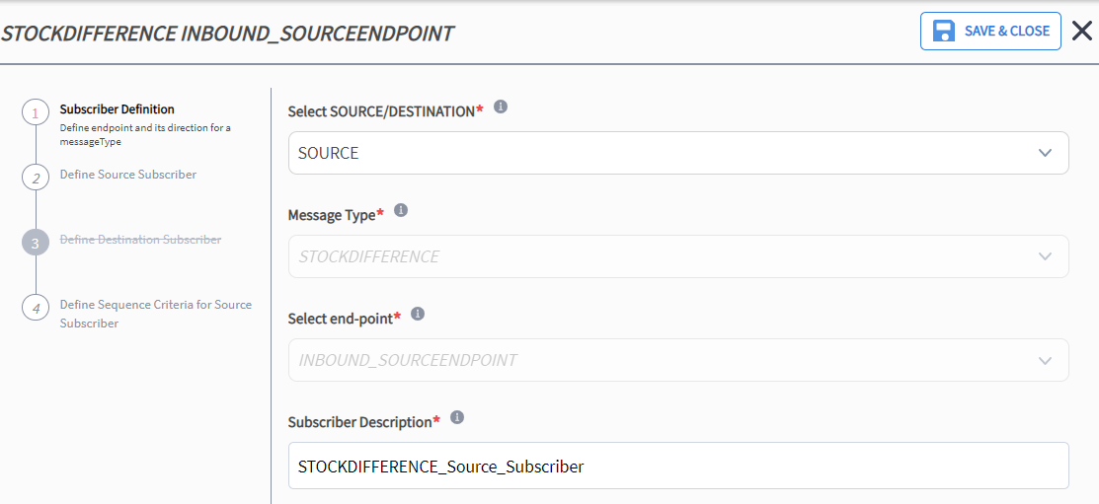

Add New

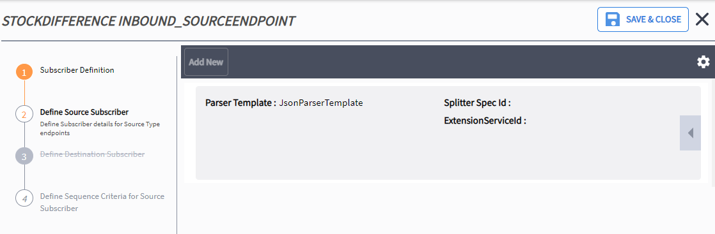

* 1. DESTINATION Transport

Configure the destination transport in Transport UI. Source transport was Direct. Destination transport will be APWF to imitate the WCS

Select the Transport UI in Warehouse Execution. Create New

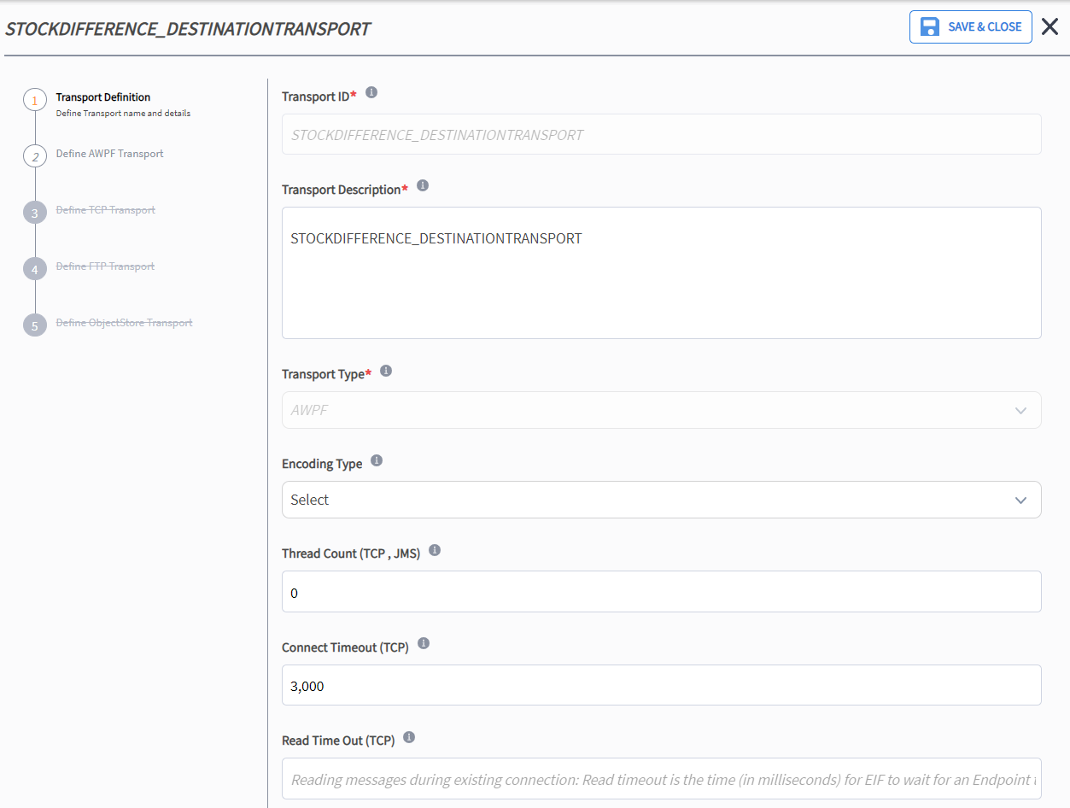

Add New and Add Extension Point ID

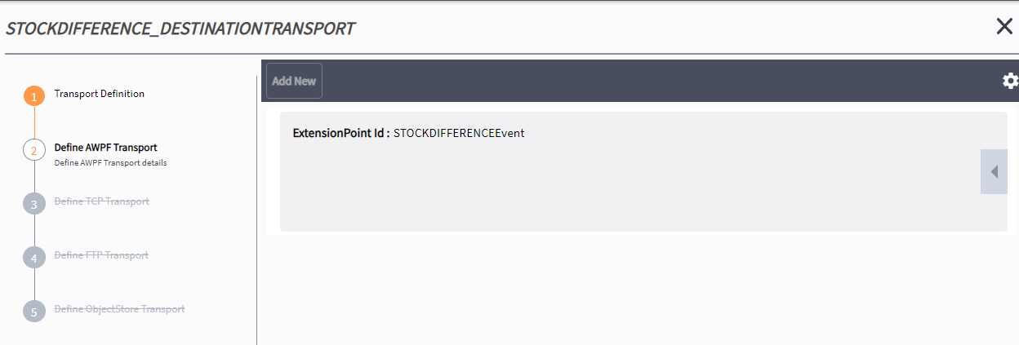

* 1. DESTINATION Endpoint

Configure the DESTINATION Endpoint. The associated DESTINATION transport must be selected.

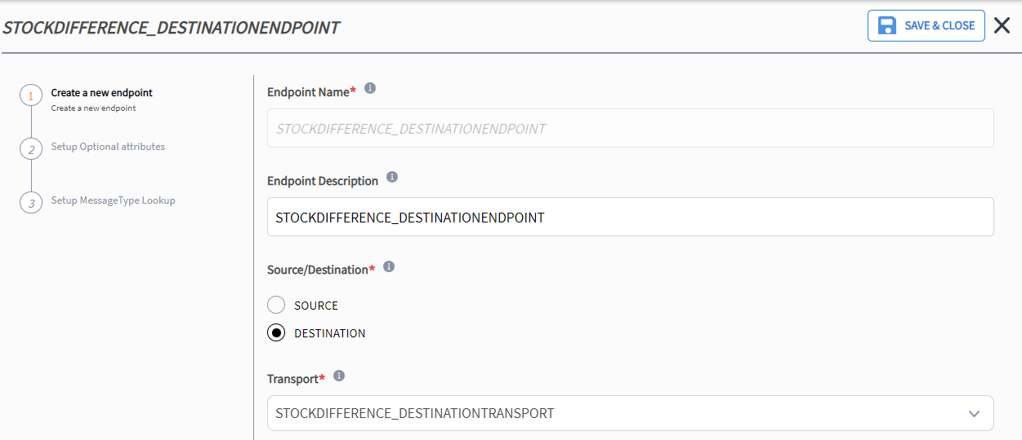

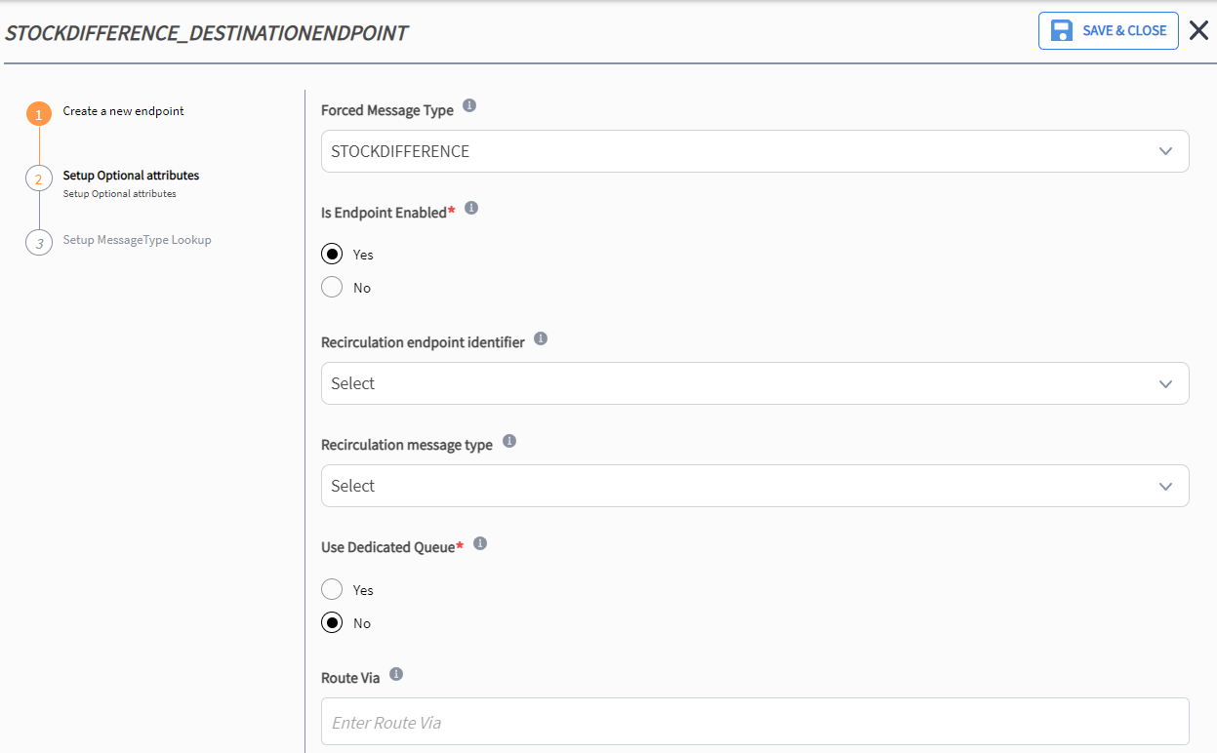

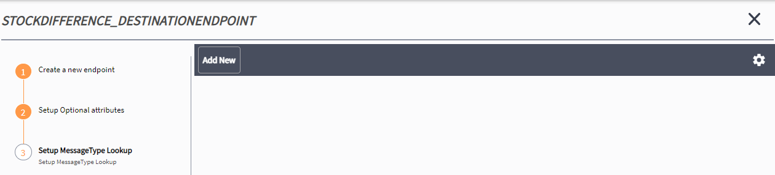

* 1. DESTINATION Subscriber

The DESTINATION subscriber links the endpoint to the Transformer Template.

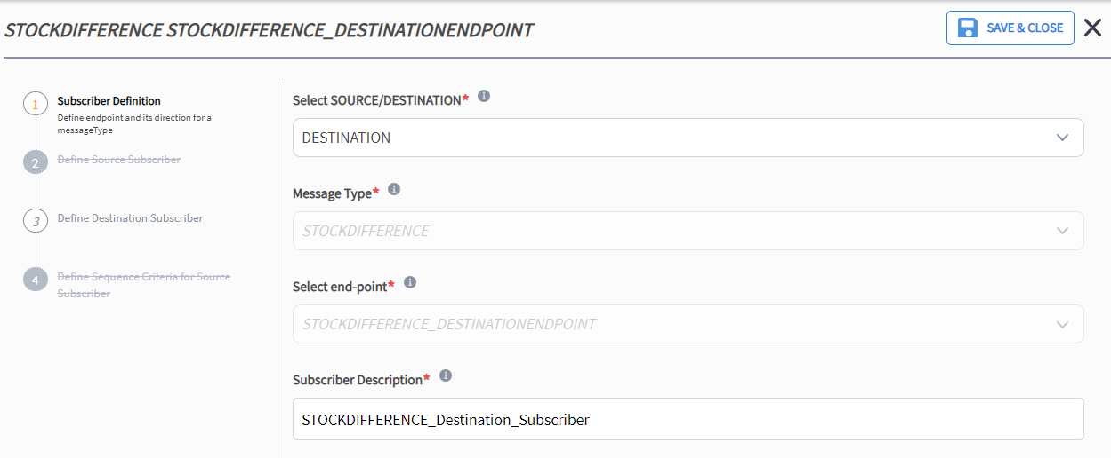

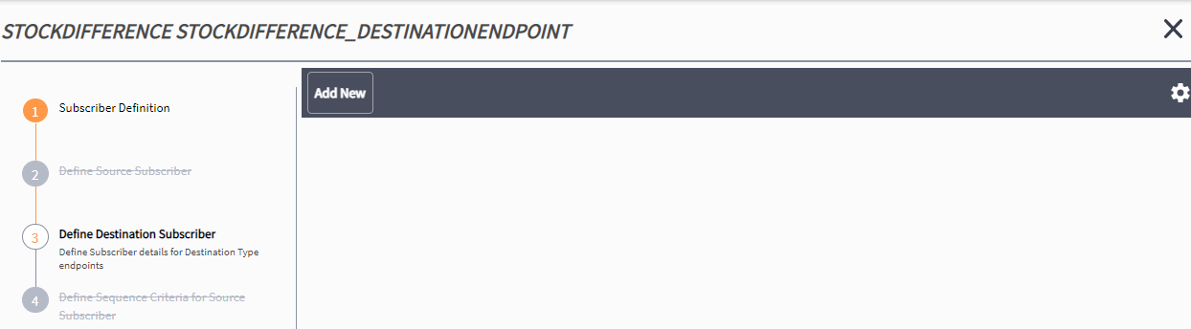

* 1. Message Routing Strategy UI

A message routing strategy is set up for each individual payload message to route the messages via the endpoints.

A new strategy will need to be created for custom message type STOCKDIFFERENCE.

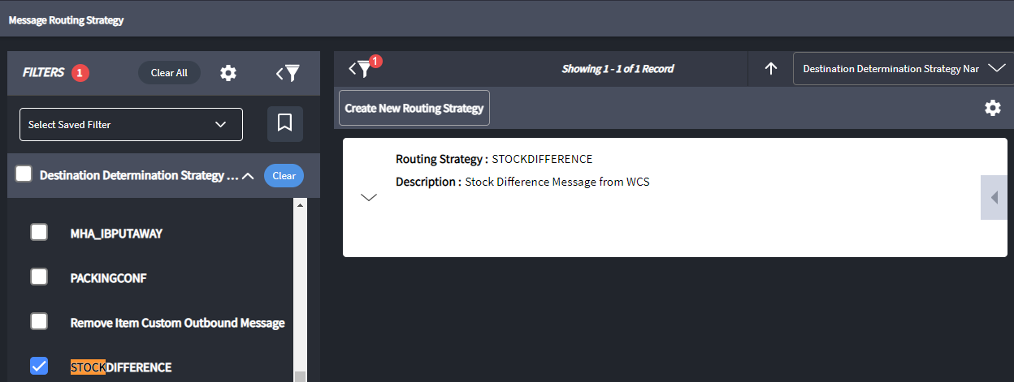

Create new routing strategy

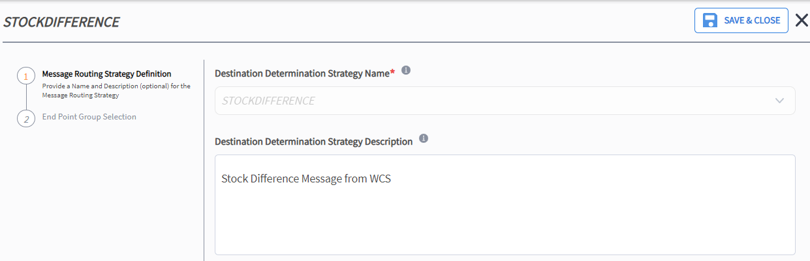

Add new end point group

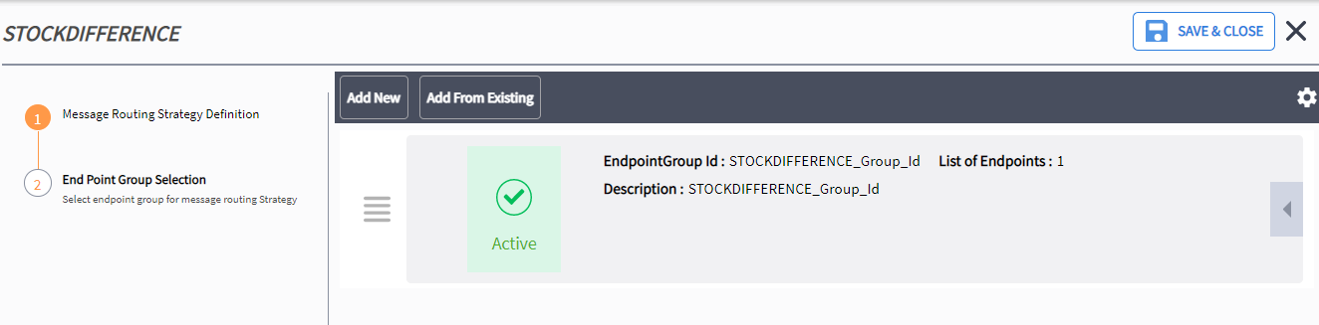

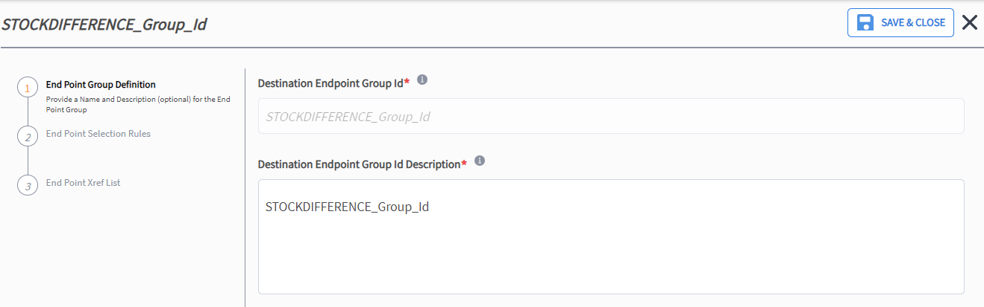

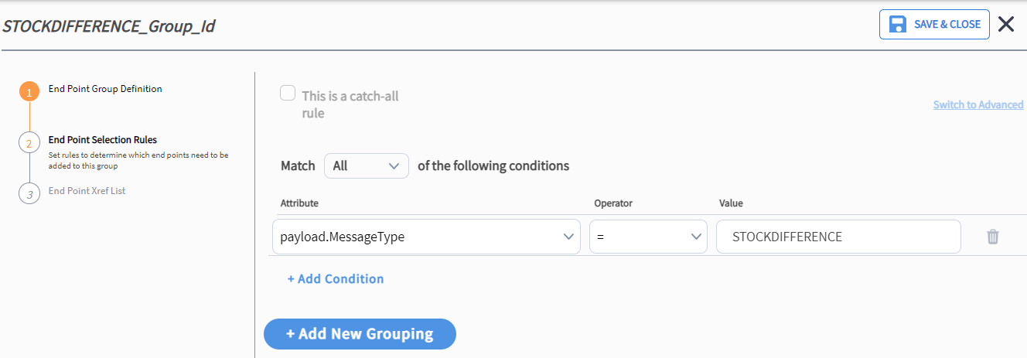

Add the Destination Endpoint previously configured.

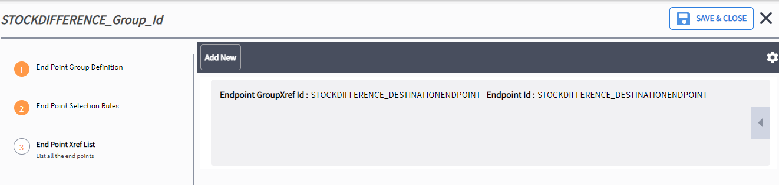

* 1. Inbound Message Type

The inbound message types can be viewed within proactive. Unlike outbound message types there is no requirement to enable. As this is a custom message, an inbound message type needs to be added. This config will be added at a later date upon advice from technical team.

1. JSON Example Output
   1. Message Format

All messages, both outbound (MAWM to VISION via AIL) and inbound (VISION to MAWM via AIL) will be in JSON format.

{

    "EndpointId": "INBOUND_SOURCEENDPOINT",

    "IncludeRequest": **true**,

    "Message": [

        {

            "MessageType": "STOCKDIFFERENCE",

            "MessageId": "12345678",

            "ItemId": "12345678",

            "Quantity": "12345678",

            "ReasonCode": "12345678",

            "IlpnId": "12345678",

            "UserId": "12345678",

            "ObjectType": "StockDifference"

        }

    ]

}

* 1. Escaping of Special Characters

If the source data contains special characters, the FOR JSON clause escapes them in the JSON output with \, as shown in the following table. This escaping occurs both in the names of properties and in their values.

|  |  |
| --- | --- |
| Special character | Escaped output |
| Quotation mark (") | \" |
| Backslash (\) | \\ |
| Slash (/) | \/ |
| Backspace | \b |
| Form feed | \f |
| New line | \n |
| Carriage return | \r |
| Horizontal tab | \t |

1. Message Mapping MHE fields to MAWM Fields

|  |  |  |  |  |  |
| --- | --- | --- | --- | --- | --- |
| VISION Message | VISION Field | Type | MAWM JSON Message | MAWM Definition | JSON field |
| StockDifference | MessageID | String(48) | STOCKDIFFERENCE | Payload reference only | MessageId  (Mandatory) |
| StockDifference | Matchcode | String(20) | STOCKDIFFERENCE | Item | ItemId  (Mandatory) |
| StockDifference | Quantity | Integer(9) | STOCKDIFFERENCE | Quantity | Quantity  (Mandatory) |
| StockDifference | ReasonCode | String(20) | STOCKDIFFERENCE | Reason Code | ReasonCode  (Mandatory) |
| StockDifference | StockReferenceNo | String(30) | STOCKDIFFERENCE | iLPN | IlpnId  (Mandatory) |
| StockDifference | LoginID | String(30) | STOCKDIFFERENCE | User | UserId  (Mandatory) |
| N/A | N/A | String(30) | STOCKDIFFERENCE | Object Type | ObjectType  (Default value: StockDifference)  (Mandatory) |
| N/A | N/A | String(50) | STOCKDIFFERENCE | Inbound Source Endpoint | EndpointId  (Default value: INBOUND_SOURCEENDPOINT)  (Mandatory) |
| N/A | N/A | String(50) | STOCKDIFFERENCE | Message Type | MessageType  (Default value:STOCKDIFFERENCE)  (Mandatory) |
| N/A | N/A | Boolean(5) | STOCKDIFFERENCE | Include Request | IncludeRequest  (Default value:true)  (Mandatory) |

1. MHE Journal

To be confirmed

1. MHE Message Enrichment

|  |  |  |  |
| --- | --- | --- | --- |
| MAWM Message Type | JSON Field | JSON Message | Data |
|  |  |  |  |
|  |  |  |  |
|  |  |  |  |
|  |  |  |  |
|  |  |  |  |
|  |  |  |  |
|  |  |  |  |